Databases and SQL for Data Science in Python

# Getting Started with SQL

* SQL, Data, Database, Relational Database, RDBMS

## Basic SQL Commands: Create a table, Insert, Select, Update, Delete

* Statements;

1. SELECT, WHERE
2. COUNT: No. of rows

DISTINCT: Unique rows

LIMIT: first x number of rows

OFFSET: Starting from a particular row

1. INSERT

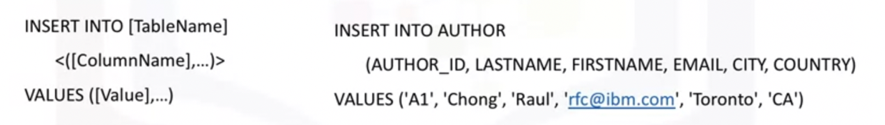

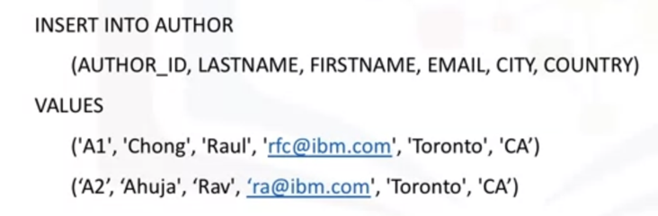

1. UPDATE (Remember to use WHERE clause)

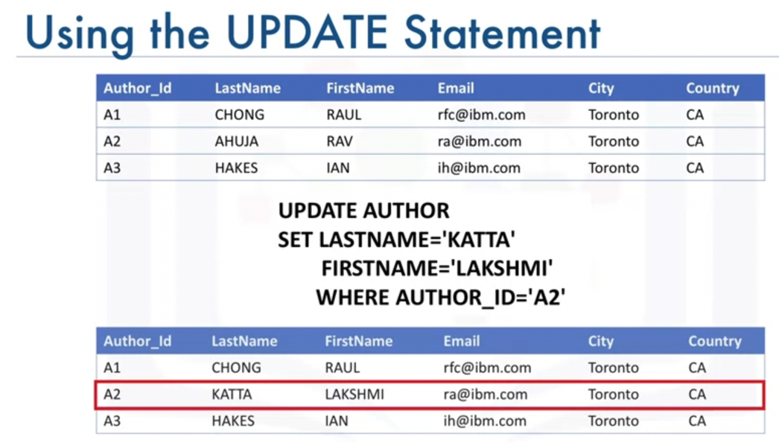

1. DELETE(Remember to use WHERE clause)

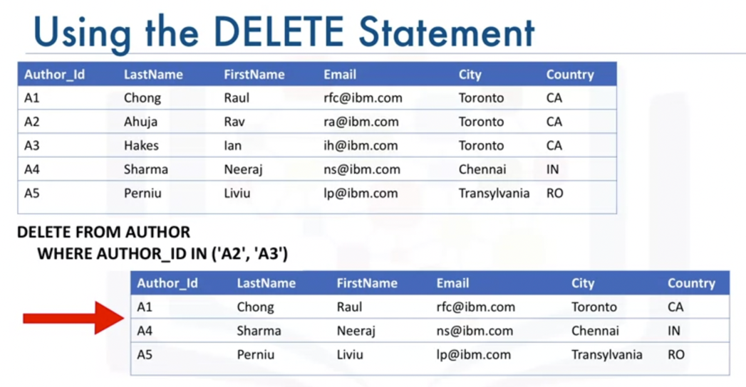

## Summary

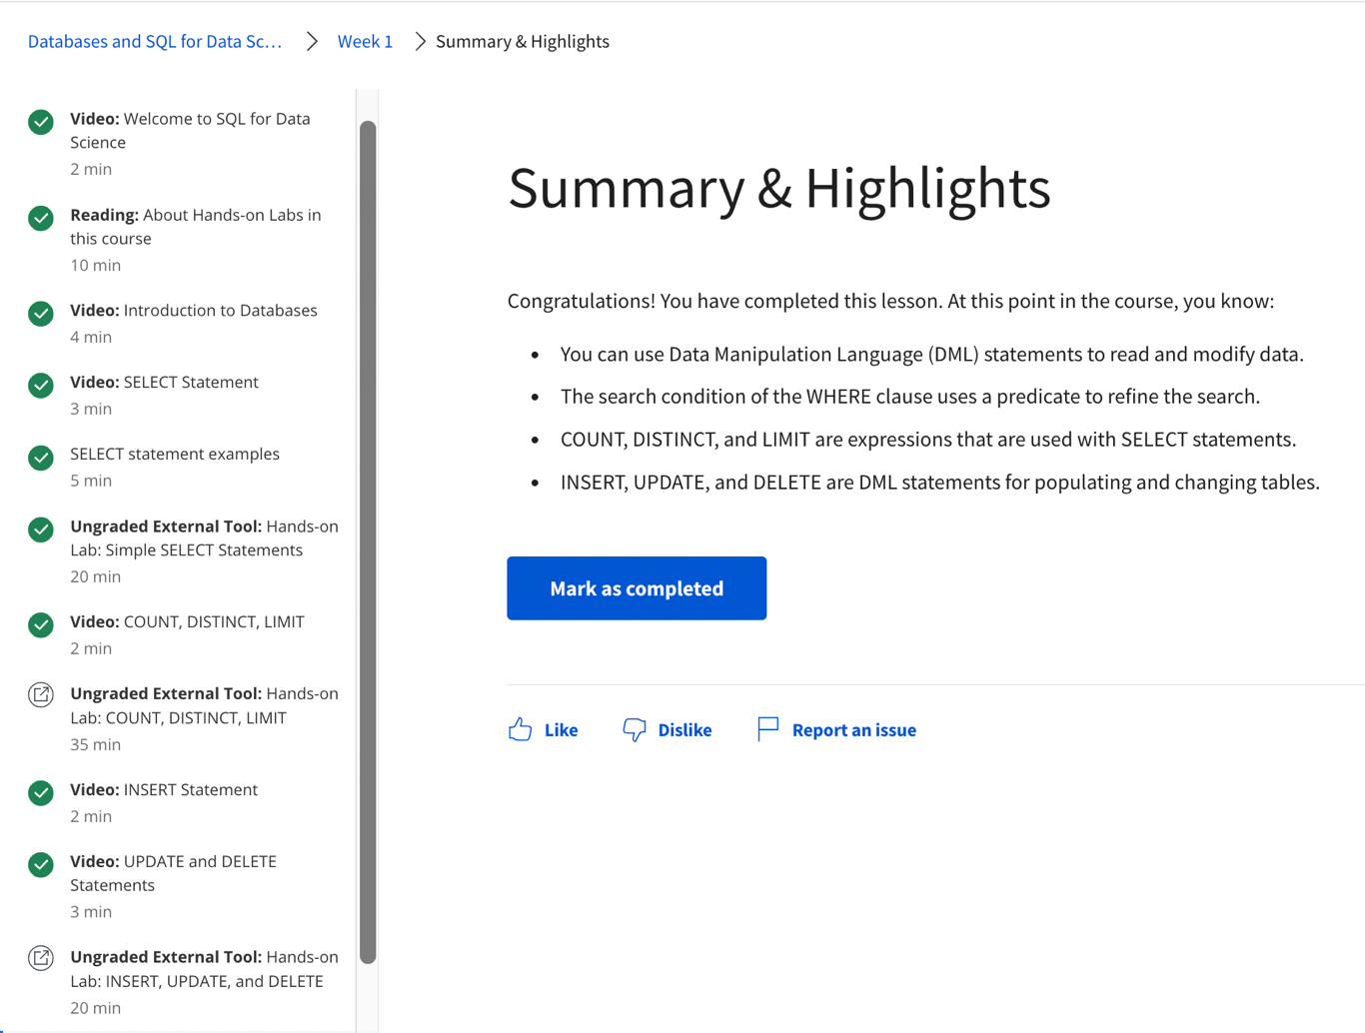

# Introduction to Relation Databases and tables

## Relational Database Concepts

* Relational Model
* Entity Relationship (ER) Model
* Mapping Entity Diagrams to Tables
* Primary and Foreign Keys

## Types of SQL Statements (DDL vs DML)

### Data Definition Language (DDL)

* Define, Change or Drop Data in tables
* CREATE, ALTER, TRUNCADE, DROP

### Data Manipulation Language (DML)

* Read and modify data
* CRUD operations
* INSERT, SELECT, UPDATE, DELETE

## CREATE

* names of columns
* datatypes of columns
* constraints (primary key, NOT NULL, etc.)

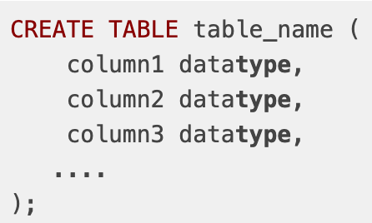

## ALTER, DROP and TRUNCATE Tables

* ADD or DROP columns, keys or constraints

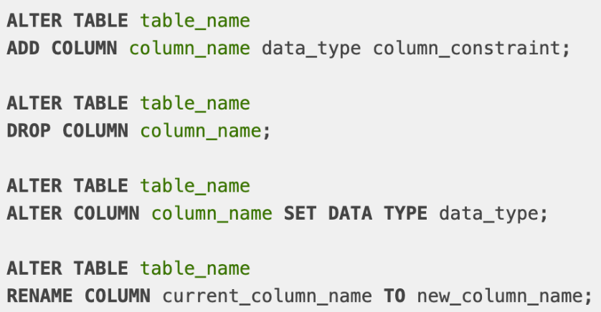

* ALTER the data type of columns

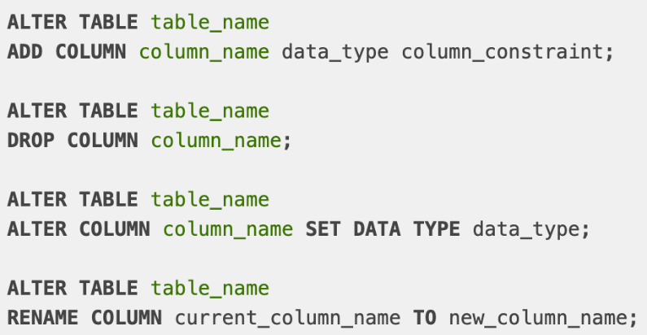

* DROP Tables

DROP TABLE <table_name>

* TRUNCATE (Delete the data in the table)

TRUNCATE TABLE <table_name> IMMEDIATE

## Summary

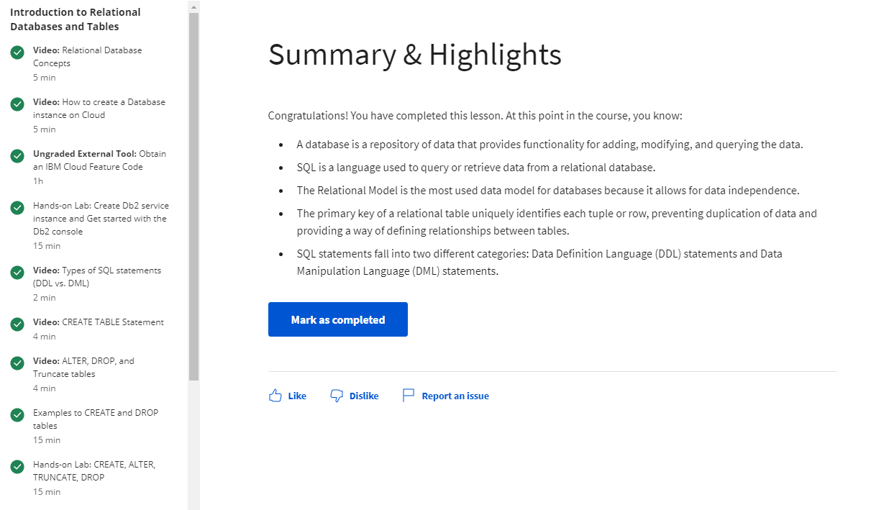

# Intermediate SQL

## Refining your Results

### Using String Patterns and Ranges (WHERE)

* String Patterns (LIKE)

SELECT * FROM Table_Name WHERE <col> LIKE “__”

* Range
* Using a Set of values (OR)\

### Soring Results Sets

* ORDER BY
* ASC/DESC

### Grouping Results Sets

* GROUP BY
* Eliminating duplicates from results set
* How to restrict a result set

### Summary

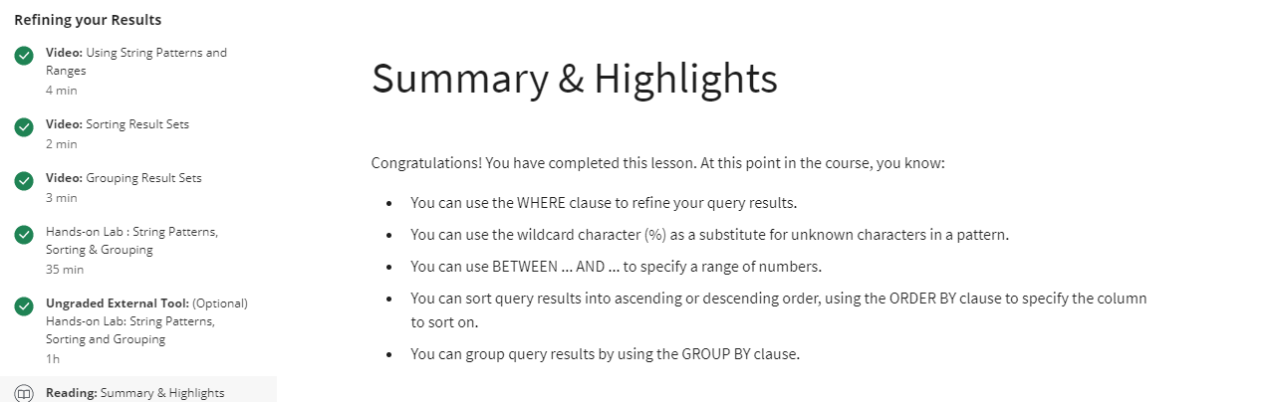

## Functions, Multiple Tables and Subqueries

### Built-in Database Functions

#### Aggregate or Column Functions

* SUM, MIN, MAX, AVG

#### Scalar or String Functions

* ROUND, LENGTH, UCASE, LCASE

### Date and Time Built-in Functions

#### Date, Time Functions

* YEAR. MONTH, DAT, DAYOFMONTH, DATYOFWEEK, DAYOFYEAR, WEEK, HOUR, MINUTE, SECOND

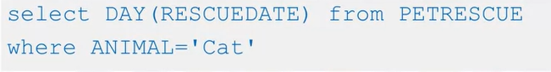



#### Date or Time Arithmetic

* CURRENT_DATE. CURRENT_TIME

### Sub-queries and Nested Selects

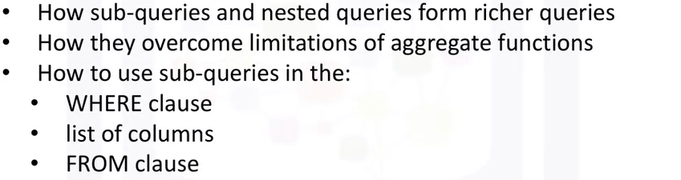

### Working with Multiple Tables

* Subqueries
* Implicit JOIN
* Join Operators (INNER, OUTER, LEFT, RIGHT etc.)

### Summary

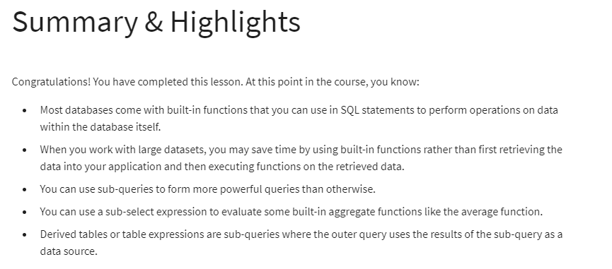

# Database Design (freeCodeCamp.org)

## Triggers

Define a certain action that should happen when a certain operation gets performed on a database.

* ALWAYS Use the SQL command line
* Difference b/w ; and $$ : Ensuring the end of SQL commands are different (Changing of the DELIMITER)
  + Eg- every time a new user is created, a trigger is created

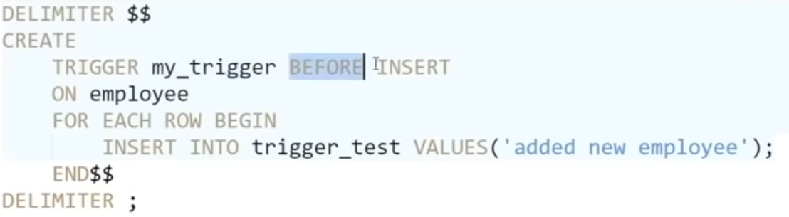

Populating table

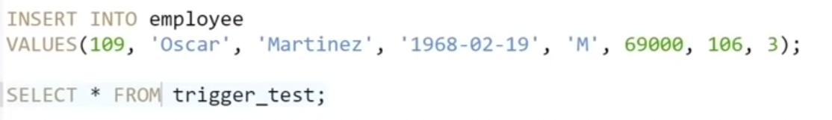

output

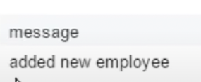

### Eg of a complex Trigger

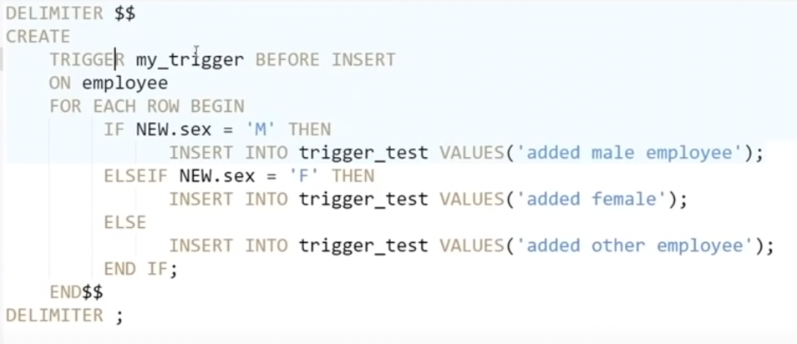

**Output will be different from above**

## Entity Relationship (ER) Diagram Intro

### Entity

#### Use <https://app.diagrams.net/>

An Object we want to model & store information about (Table Name with columns)

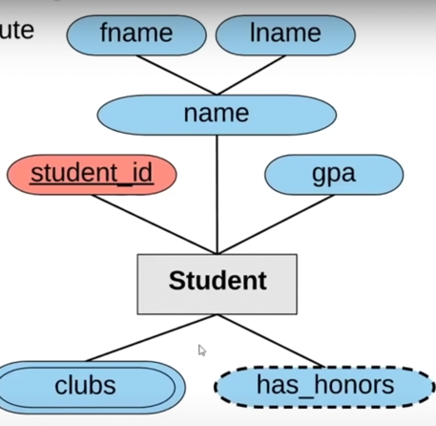

* Primary Key
* Composite Attribute: Name becomes First Name and Last Name
* Multi-values Attribute: More than one Value (clubs)
* Derived Attribute: IF GPA > 3.5, Honours == True

### Multiple Entities

Connecting Multiple tables together

* Creating Relationships
  + Patrial Participation ------
  + Total Participation =====
  + Relationship Cardinality
    - 1-1
    - 1-m
    - m-m

### Weak Entities

An Entity that can’t be uniquely identified by its attributes alone

An entity that would rely on another entity

* An exam CAN’T be uniquely identifies without a class
* ALL exams must have a class. However, all exams don’t need to have a class

## Designing an ER Diagram

* Create Tables: Primary Keys, Foreign Keys, Columns
* Create Cardinality Relationships: 1-1, 1-m, m-m
  + Defining attributes accordingly depending on the relationships
  + Eg: All branches are managed by an employee. However, not all employees are managing branches
* Some attributes can be **BOTH PRIMARY AND FOREIGN KEYS**
* Creating UML Diagrams accordingly

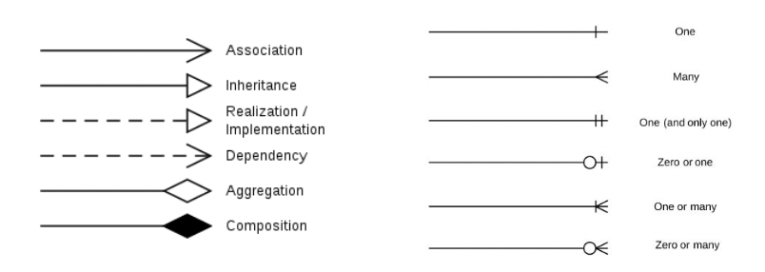

## Converting ER Diagrams to Schemas on SQL

* Create Schema
* Create Tables in the following order
  1. Tables with only primary keys
  2. Tables with Primary and foreign keys
  3. Tables with Multiple Primary and Foreign keys
  4. Parents tables
  5. Child tables
* Create Triggers
* Inputting Data
  + Insert/Update/Delete
  + Populating databases from csv files

# Accessing Databases using Python

* Using Python to Connect to a Database
* Create tables, load data, and query data using SQL
* Analyse and Visualise Data in Jupyter Notebook

## How to Access Databases using Python

* Basic concepts of connecting Python apps into a Database
  + NumPy, Pandas, matplotlib and SciPy
  + Python Database API: DB-API

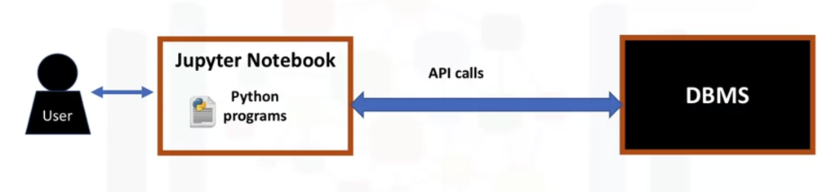

* SQL API’s

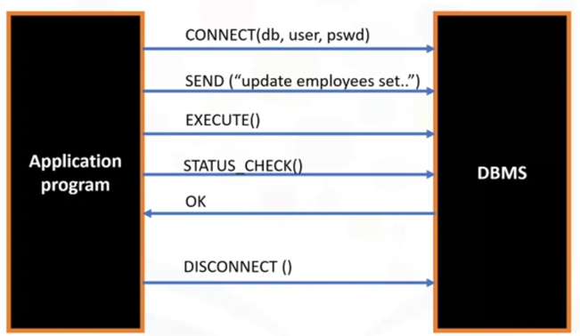

* List SQL API’s for popular RDBMSes

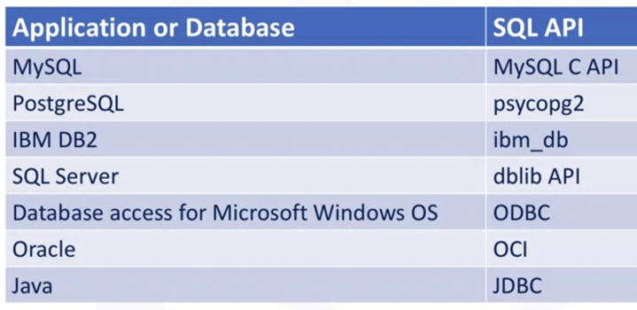

## Writing Code using DB-API

* Allowing a single program to work with multiple kinds of relational databases

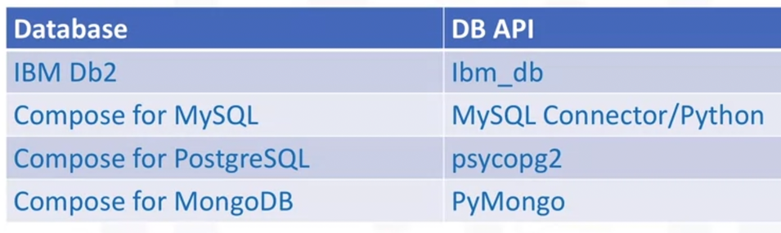

### Connection Objects

* Database Connections
* Manage Transactions

### Cursor Objects

* Database Queries
* Scroll through results set
* Retrieve Results

### Methods

|  |  |
| --- | --- |
| **Connection Methods** | **Cursor Methods** |
| * .cursor() * .commit() * .rollback() * .close() | * .callproc() * .execute() * .executemany() * .fetchone() * .fetchmany() * .fetchall() * .nextset() * .arraysize() * .close() |

### Database Cursor

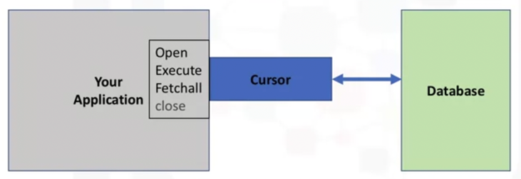

### Code

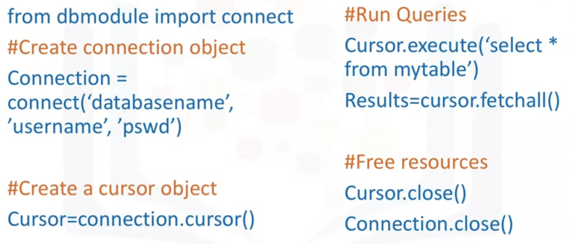

## Connecting to a Database using IBM DB-API

### Identify database connection credentials

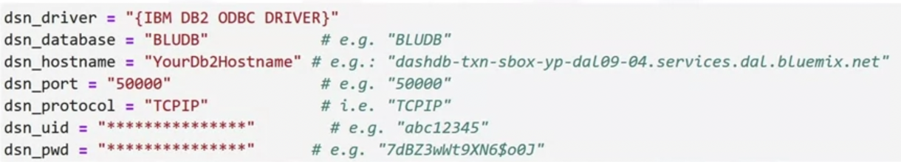

### Creating a DB2 Connection

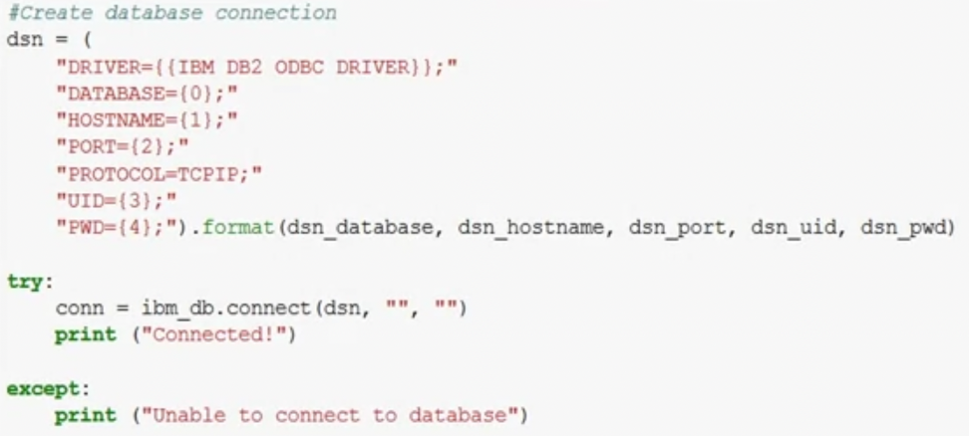

### Close the DB2 Connection

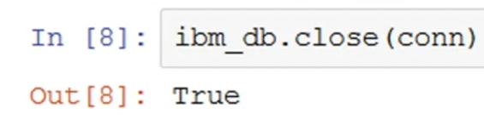

## Creating tables, loading data and querying data

## Intro and Accessing databases using SQL Magic

## Analysing data with Python

# Working with Real-World Datasets and Bult in SQL Functions

# Future References

* Regular expressions

<https://www.geeksforgeeks.org/mysql-regular-expressions-regexp/>

* Replace Function

REPLACE(column_name, 'fromStringValue', 'toStringValue')

* Count(*)

SELECT COUNT(column_name)

FROM table_name

WHERE condition;

* Triangle hacker rank question

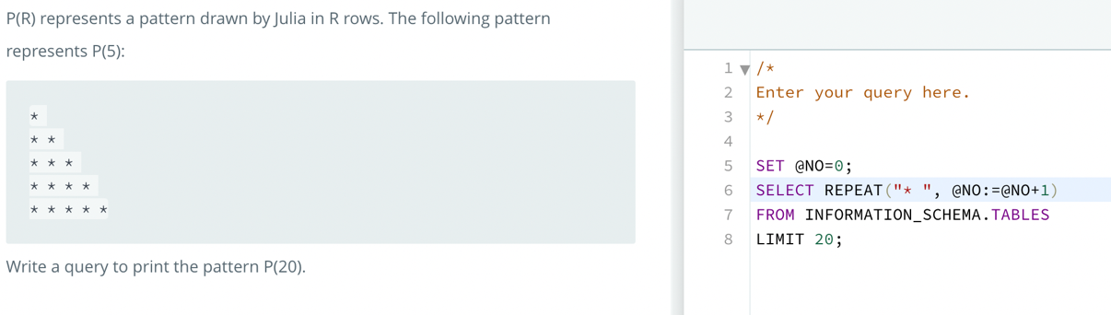

# 7. Sub Queries Details

## ER Diagrams

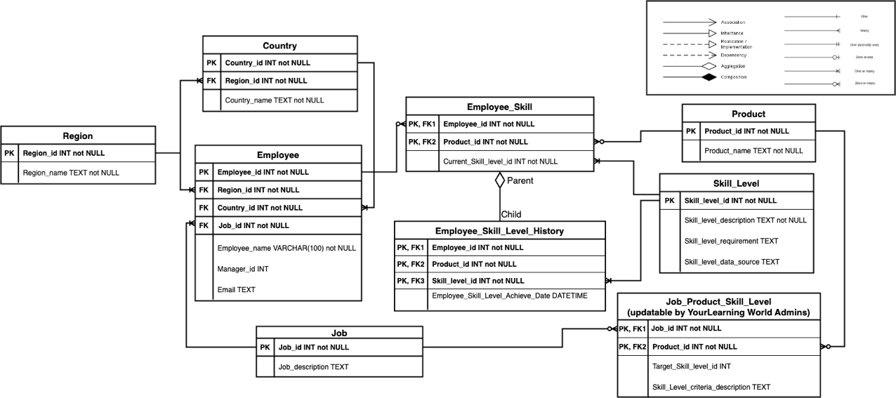

## Querying for multiple tables

* Start at a parent table
* Move to a child table based on 1-m relationship
* Move to another table (if present) based on 1-m relationship
* Once theres no more 1-m relationships;
  + INNER JOIN the other side of the parent table to the child tables accordingly
  + Create a sub query out of the first parent table

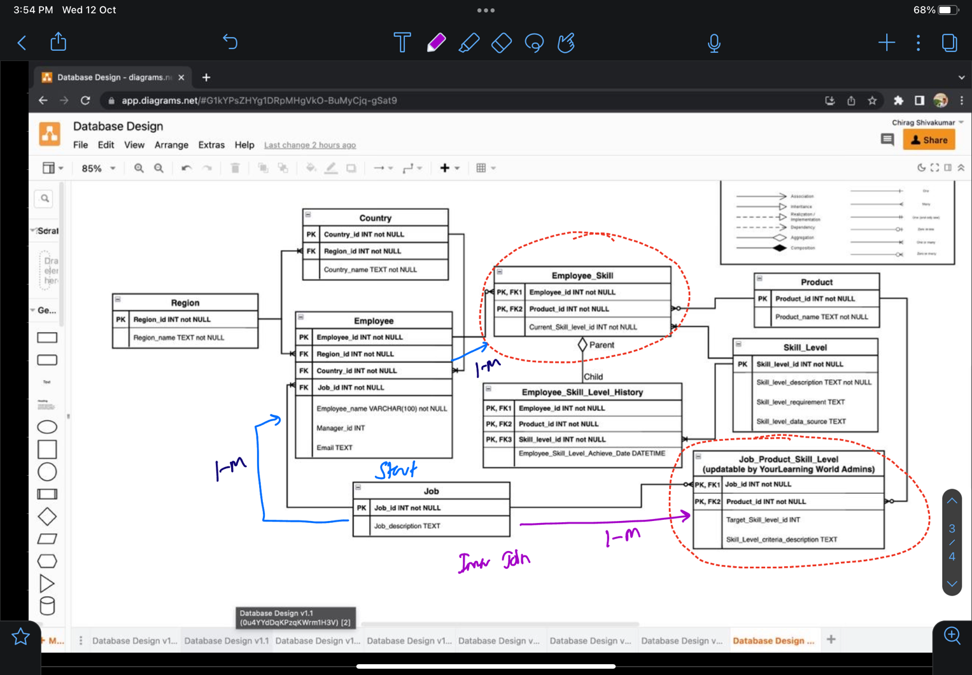

### Example of query

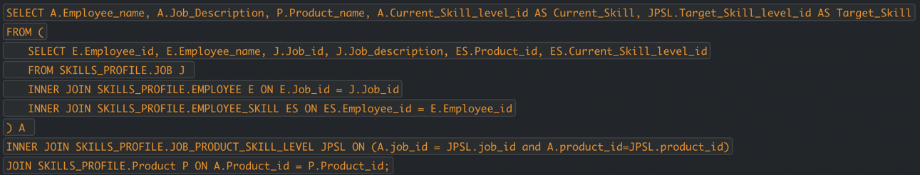

## Summary

### 1(A table) : M ( B table)

* primary key columns of A table : Many rows with that key columns of A table.

### M : M

* Group query by one side based on join key columns
* INNER JOIN- Group query by other side based on join key columns